Software Design Document   
Victoria Accident Data Visualisation Project

Student Names

* Max Woollons
* Kail Terepai
* Reiss Tooze

**Table of Contents**

1.0 System Vision 3

1.1 Problem Background 3

1.2 System Overview 3

1.3 Potential Benefits 3

2.0 Requirements 4

2.1 User Requirements 4

2.2 Software Requirements 4

2.3 Use Cases & Use Case Diagrams 5

3.0 Software Design and System Components 7

3.1 Software Design 7

3.2 System Components 7

3.2.1 Functions 7

3.2.2 Data Structures / Data Sources 7

3.2.3 Detailed Design 7

4.0 User Interface Design 8

4.1 Structural Design 8

4.2 Visual Design 8

# System Vision

## Problem Background

A visualisation tool needs to be developed to best communicate data from the Victoria State Accident Dataset provided by Vicroads (Australia). This data contains information from 74,908 road-based accidents that happened on Victorian roads between 2015 and 2020. The dataset contains information relating to date, time, location, type of accident, short description of what happened, type of vehicle, number of vehicles, alcohol involvement, if it was a hit and run, speed limits on the road and many other relevant details. A visualisation tool needs to be created to better communicate insights from the data to relevant stakeholders.

## System Overview

The system itself will be built using python and utilise python libraries such as pandas, matplotlib, seaborn, and tkinter ### Insert other libraries as needed###. The application will read a dataset, then show various visualisation options to a user using a GUI. Relevant data selection options will be displayed from which the user will then be able to make their selection from which the relevant data will be visualised for user interpretation.

Users will be able to select visualisation options which include:

* Display the information of all accidents that happened in a user-selected period.
* For a user-selected period, produce a chart to show the number of accidents in each hour of the day (on average).
* For a user-selected period, retrieve all accidents caused by an accident type that contains a keyword (user entered), e.g. collision, pedestrian.
* Allow the user to analyze the impact of alcohol in accidents – ie: trends over time, accident types involving alcohol, etc.
* For a user-selected year, display the information of all accidents that occurred on a Victorian public holiday within the selected year.

## Potential Benefits

This tool will allow for effective interpretation and filtering of relevant data from the Victoria State Accident Dataset. This dataset is large, not very end-user friendly and does not effectively show relevant data which could be useful for the user. Potential benefits for end-users include:

* Effective filtering and visualisation of accidents across date ranges.
* Effective filtering and visualisation of accidents across each hour of the day. This could mean that the user will be able to retrieve the time of day when an accident is either most likely or previously occurred.
* Effective keyword searching for relevant accident keywords to produce visualisation outcomes.
* Effective visualisation of alcohol related accidents.
* Effective visualisation of accidents on public holidays based on year.

# Requirements

## User Requirements

In this section you detail how a user is supposed to interact with or use your program. What do they ***need*** to be able to do? This should all be from the end users perspective. Can be a combination of narrative text and listing of needs.

**Assignment note: You have not been given a client/user, so you can make one up. Who do you think would be using your software?**

Users will be able to execute the software, input and or select relevant query parameters, then based on selection will be shown a visualisation of the data from the Victoria State Accident Dataset.

A user may be a relevant public servant, politician or member of the public with an interest in the data. Users will need to be able to access the program through an executable file. The user will then be presented with options for the data visualisation. These options will provide the user with the ability to:

* Specify a time period in the software and be shown data relating to the specified time period.
* Specify a time period in the software and be shown the average amount of accidents across a day at hourly intervals.
* Enter keywords relating to the accident and for the software to search and show data relating to the entered keyword(s).
* Clearly see the impact that alcohol has in Victorian accidents through visualisation.
* Select a year and view relevant data relating to accidents on public holidays.

With each requirement, users will need to have the ability to export the generated data for external use.

## Software Requirements

In this section you detail what the requirements for the software are. What functionality will it provide? This is usually a formal listing, with requirements often using the word ‘Shall’. IE:

R1.1 The program shall accept multiple file names as arguments from the command line.

R1.2 Each file name can be a simple file name or include the full path of the file with one or more levels.

etc …

Can be primarily functional requirements, though you may include other types if you think of them.

Draft:

* R1 The program shall accept a csv document for data interpretation.
* R2.1 The program shall filter data from the csv document.
* R2.2 The program shall create charts based on data from the csv document.
* R2.3 The program shall allow exporting of generated charts and other visualisations.

## 

## Use Cases & Use Case Diagrams

Use Cases:

Table 1 was created to show all of the use cases for the Victoria Accident Data Project. The table shows the use cases, users and description of the use case.

| **Use Cases with Descriptions: Victoria Accident Data Visualisation Project** | | |
| --- | --- | --- |
| Use Case | Users | Description |
| View visualisation relating to crashes over a user-specified period of time. |  | User opens the application (if not already open) then selects the ‘crashes over a period of time’ option. The user then will be shown the visualisation of all data by default but will be able to make a date range selection and click a ‘generate’ button to update the data being presented. |
| View visualisation relating to the average number of accidents in each hour of the day over a user-specified period of time. |  | User opens the application (if not already open) then selects the ‘average crashes based on time’ option. The user then will be shown the relevant visualisation of all data by default but will be able to make a date range selection and click a ‘generate’ button to update the data being presented. |
| View visualisation of crash data to a specified keyword/s. |  | User opens the application (if not already open) then types in a keyword or keywords. The application then filters the data and shows the user the relevant data and visualisation. If nothing is entered, all data will be used. |
| View visualisation relating to the impact of alcohol in the accidents. |  | User opens the application (if not already open) then selects the ‘Impact of Alcohol’ option. Users are then shown a visualisation comparing crashes involving alcohol vs not involving alcohol. |
| View visualisation relating to crashes on public holidays over a period of time. |  | User opens the application (if not already open) then selects the ‘Public Holiday insights’ option. |

Table 1: Use case descriptions

Use Case Diagrams: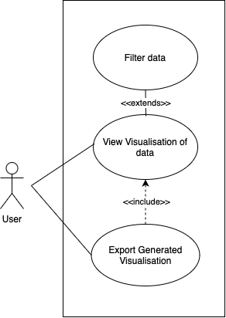

Figure 1 shows the use case diagram for use case one & two. Although both use cases operate similarly they produce different data for users interpretation.

* View visualisation relating to crashes over a user-specified period of time
* View visualisation relating to the average number of accidents in each hour of the day over a user-specified period of time.

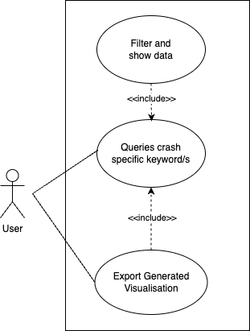

Figure 1 - Use case one and two diagram

Figure 2 shows the use case diagram for use case three ‘View visualisation of crash data to a specified keyword/s.’

Figure 2 - Use case three diagram

Figure 3 shows use case four diagram ‘View visualisation relating to the impact of alcohol in the accidents.’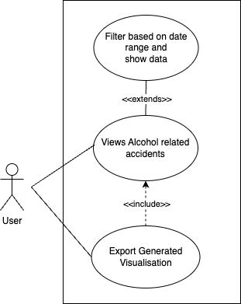



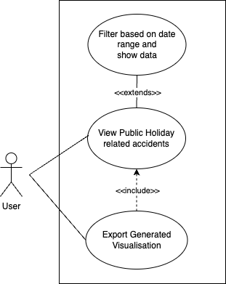

Figure 4 shows use case five diagram ‘View visualisation relating to crashes on public holidays over a period of time.’

# 

# Software Design and System Components

## Software Design

## 3.2 System Components

### Functions

Preliminary list of all functions in the software. For each function in the list the following information is provided:

* a brief description of what it does (1 or 2 sentences);
* a list of the input parameters, and their data types, and what they are used for;
* a list of any side effects caused by the function (ie change global or member variables, changes data passed by reference from calling function etc)
* a description of the function’s return value

### Data Structures / Data Sources

List of all data structures in the software (eg linked lists, trees, arrays etc) or eternal data sources. For each data structure in the list the following information is provided:

* Type of structure (tree, list etc),
* Description of where and how it is used
* List of data members, and what each one is for do
* List of functions that use it

### Detailed Design

Pseudocode for all non-standard / non-trivial algorithms that operate on data structures

# User Interface Design

This is your initial interface design. Describe the tools you used for this design stage and any key findings that informed your design. This introduction is descriptive and should explain what you have completed for the actual design work you will present in the sub-sections below.

## Structural Design

Structural design refers to the navigational and information structure of your product – the structure that supports the interface layout. How will you structure your product? How will you group your information? How will you navigate through your product? Why? This can take the form of a diagram showing structure and hierarchy, supported by a discussion and justification of your choices. Why have you made these design choices? Describe and outline the structure of your interface and of your information.

## Visual Design

Detail your visual design: Layout, visual elements, icons, graphics, style, colour, fonts general screen designs. This can be sketches, wireframes, mockups etc, supported by a discussion, explanation, and justification of your choices.

Functionality and data that is shown:

Use Case 1

View visualisation relating to crashes over a user-specified period of time.

Data to be shown:

* Days of the week with the most accidents
* Most common crash type
* Deadliest day to drive.
* Most common daylight condition to crash.

Use Case 2

View visualisation relating to the average number of accidents in each hour of the day over a user-specified period of time.

Data to be shown:

* Most common accident type by hour
* Deadliest suburb
* Number of fatalities in each hour.
* Most dangerous speed zone.

Use Case 3

View visualisation of crash data to a specified keyword/s.

Data to be shown:

* Number of crashes with keyword/s
* Speed Zones
* Number of crashes with fatalities
* Number of alcohol to non alcohol related crashes

Use Case 4

View visualisation relating to the impact of alcohol in the accidents.

Data to be shown:

* Accidents relating to alcohol vs accidents non alcohol related
* Top 3 suburbs with the most alcohol related crashes
* Fatal accidents alcohol vs non alcohol
* Most common speed zone with crashes relating to alcohol vs not.
* Pedestrians struck alchohol vs not alcohol.

Use Case 5

View visualisation relating to crashes on public holidays over a period of time.

Data to be shown:

* Top 3 most dangerous public holidays to drive
* Deadliest public holidays
* Public holidays with the most alcohol related crashes